##### A Project Report On

**VISUALIZING AND FORECASTING OF STOCKS**

###### A Dissertation submitted to JNTU Hyderabad in partial fulfillment of the academic requirements for the award of the degree.

**Bachelor of Technology**

**IN**

**Computer Science and Engineering**

Submitted by

Bhanu Prasad Reddy (20H51A0528)

Balaji Bhandare (20H51A0531)

Tammana Sachit (20H51A0552)

Bhanu Prasad Reddy (20H51A0528)

Balaji Bhandare (20H51A0531)

Tammana Sachit (20H51A0552)

Under the esteemed guidance of

**(Ms. M.N. Sailaja)**



**Department of Computer Science and Engineering**

**CMR COLLEGE OF ENGINEERING AND TECHNOLOGY**

(An Autonomous Institution under UGC & JNTUH , Approved by AICTE, Permanently Affiliated to JNTUH, Accredited by NBA.)

KANDLAKOYA, MEDCHAL ROAD, HYDERABAD - 501401.

2020- 2024

**CMR COLLEGE OF ENGINEERING & TECHNOLOGY**

KANDLAKOYA, MEDCHAL ROAD, HYDERABAD – 501401

**DEPARTMENT OF COMPUTER SCIENCE AND ENGINEERING**

#### CERTIFICATE

This is to certify that the Mini Project-1 report entitled **"VISUALIZING AND FORECASTING OF STOCKS"** being submitted by **A. Bhanu prasad (20H51A0528), T. Sachit (20H51A0552), Balaji (20H51A0531)**in partial fulfillment for the award of **Bachelor of Technology in Computer Science and Engineering** is a record of bonafide work carried out his/her under my guidance and supervision.

###### The results embody in this project report have not been submitted to any other University or Institute for the award of any Degree.

**MS. M. N SAILAJA DR. S. SIVA SKANDHA**

**Dept. of CSE Professor and HOD**

**Dept. of CSE**

##### ACKNOWLEDGEMENT

With great pleasure We want to take this opportunity to express my heartfelt gratitude to all the people who helped in making this project work a grand success.

We are grateful to **MS. M.N. Sailaja**, Dept of Computer Science and Engineering for his valuable technical suggestions and guidance during the execution of this project work.

We would like to thank **Dr. S. Siva Skandha,** Head of the Department of Computer Science and Engineering, CMR College of Engineering and Technology, who is the major driving forces to complete my project work successfully.

We are very grateful to **Dr. Vijaya Kumar Koppula**, Dean-Academic, CMR College of Engineering and Technology, for his constant support and motivation in carrying out the project work successfully.

We are highly indebted to **Dr. V A Narayana,** Principal, CMR College of Engineering and Technology, for giving permission to carry out this project in a successful and fruitful way.

We would like to thank the Teaching & Non- teaching staff of Department of Computer Science and Engineering for their co-operation

Finally, I express my sincere thanks to **Mr. Ch. Gopal Reddy**, Secretary, CMR Group of Institutions, for his continuous care. I sincerely acknowledge and thank all those who gave support directly and indirectly in completion of this project work.

**NAME ROLL NO**

A. BHANU PRASAD REDDY (20H51A0528)

BALAJI BHANDARE (20H51A0531)

TAMMANA SACHIT (20H51A0552)





**DECLARATION**

We hereby declare that results embodied in this Report of Project on **“VISUALIZING AND FORECASTING OF STOCKS”** are from work carried out by using partial fulfillment of the requirements for the award of B. Tech degree. We have not submitted this report to any other university/institute for the award of any other degree.

**NAME**  **SIGNATURE**

A. BHANU PRASAD REDDY

BALAJI BHANDARE

TAMMANA SACHIT

**TABLE OF CONTENTS**

|  |  |  |  |
| --- | --- | --- | --- |
| **CHAPTERS** | | **DESCRIPTION** | **PAGE No** |
|  |  | **Abstract** | 3 |
| **1** |  | **Introduction** | 4 |
|  | 1.1 | Objective | 4 |
| **2** |  | **Existing solutions** | 4 |
| **3** |  | **Proposed System** | 5 |
|  | 3.1 | Proposed solution | 5 |
|  | 3.2 | Description | 6 |
|  | 3.3 | Requirements | 7 |
|  | 3.4 | Modules in system | 8 |
|  | 3.5 | How it works | 9 |
| **4** |  | **Diagrams** | 11 |
|  | 4.1 | phase Diagram | 11 |
|  |  |  |  |
| **5** |  | **Results and Discussions** | 12 |
|  | 5.1 | Working prototype images | 13 |
|  | 5.2 | Future scope | 14 |
|  | 5.3 | Screenshots of execution | 15 |
| **6** |  | **Summary and conclusion** | 18 |
|  | 6.1 | Conclusion | 18 |
|  | 6.2 | References | 19 |

**FIGURES**

|  |  |  |  |
| --- | --- | --- | --- |
| **CHAPTER** | | **NAME** | **PAGE NO** |
| **4** |  |  |  |
|  | 4.1 | DIAGRAM | 11 |
| **5** |  |  |  |
|  | 5.1 | Working prototype image | 13 |
|  | 5.2 | Working prototype image | 13 |
|  | 5.3 | Screenshot of execution | 15 |
|  | 5.4 | Screenshot of execution | 15 |
|  | 5.5 | Screenshot of execution | 16 |
|  | 5.6 | Screenshot of execution | 16 |
|  | 5.7 | Screenshot of execution | 17 |

**ABSTRACT**

* The stock market is a transformative, non-straight dynamical and complex system, long term investment is one of the major investment decisions.
* In modern financial market, the most crucial problem is to find essential approach to outline and visualizing the predictions in stock-markets made by individuals in order to attain maximum profit by investments.
* Though, evaluating shares and calculating elementary values for companies for long term investment is difficult. In this paper we are going to present comparison of machine learning aided algorithms to evaluate the stock prices in the future to analyse market behaviour.
* Our method is to correctly use machine learning algorithm and to predict the future stock market prices in the market.

**1. INTRODUCTION**

* Exchanging the stocks on money markets is one of the significant practiced exercises, in current scenario many scientists developed different stock forecasting systems that could give insight to them to envision the stock prediction development.
* Predicting and foreseeing of significant worth future cost, in perspective of the present cash related information and news, is of significant use to the financial advisors and users.
* Financial users always want to know when stock will get higher or lower over particular time so, to obtain such informational output we use machine learning algorithm.
* Using the given output, we can achieve higher levels of probability of predicting the stocks of future cost.

OBJECTIVE

We have created a single page web application using dash and machine learning models. The main goal of this project is to precisely predict the future closing price of stock over a period of time in future.

**EXISTING SOLUTIONS**

The Current System is a computerized system but which is maintained at individual databases. The system doesn’t provide complete online services like online reports, and centralized databases. In the current all the data is maintained mostly manual and in Excel Sheets. The data security and data accessing is very slow.

**Drawbacks in existing system:**

* The data accessing from the database is very slow.
* The current system takes time in retrieving a single record from the database.

**PROPOSED SYSTEM**

## PROPOSED SOLUTION:

As per prediction system, developed in the stock price prediction to help investors in making financial decisions. In most researches it focuses on "lowest price buy", "highest selling price". On the "lowest buy" and "highest selling" strategy of stocks occurs when stocks are at the lowest price and sell shares when prices are highest. In this project we have used dash html components and dash core components to create website’s structure and for enhancing the site’s UI we have used CSS for styling. Plots of data are generated by using the plotly library of python and the data is fetched using yfinance. Machine learning models are implemented for predicting the stock price for the dates requested by the user. For this project we will be using a Long Short-Term Memory network – usually just called “LSTMs” to predict the closing price using a data set of past prices. we have learned to use it because it is very advanced and performs this task very accurately and the result is more accurate. The output of the proposed system is to predict the list of stock price. At the end of system, the user can view the final result of predicted value of stock market.

**Advantages of Proposed system:**

* This system provides fast data accessing when compared to the current system.
* Here we can use the custom number of days to forecast the stocks unlike limited number of days and the model is user friendly.

**DESCRIPTION**

* Our project can tell in a very precise way where the market will move by analyzing things. We did this work by taking data from yfinance.
* We imported this data through library and analyzed with the help of machine learning model and we did it with a machine learning model because it does this thing very precisely.
* In this project we have used dash html components and dash core components to create website’s structure and for enhancing the site’s UI we have used CSS for styling. Plots of data are generated by using the plotly library of python and the data is fetched using yfinance.
* We imported this data through library and analysed with the help of machine learning model and we did it with a machine learning model because it does this thing very precisely.
* In this we have used the model of Deep Learning LSTM, we have trained the data in its own way, we have learned to use it because it is very advanced and performs this task very accurately and the result is more accurate.

**SYSYEM REQUIREMENTS**

**HARDWARE REQUIREMENTS:**

HARDWARE SPECIFICATION: SERVER

PROCESSOR: INTEL P-IV (OR ABOVE)

RAM: 512 MB (OR ABOVE)

HARD DISK: 1 GB (OR ABOVE)

CLIENT PROCESSOR: CELERON 500 MHZ OR MORE, INTEL

PENTIUM III (OR ABOVE)

RAM: 128 MB RAM (OR ABOVE)

HARD DISK: 1 GB (OR ABOVE)

**SOFTWARE REQUIREMENTS:**

OPERATING SYSTEM: WINDOWS 7/8/10 or LINUX

PLATFORM: VISUAL STUDIO CODE

PROGRAMMING LANGUAGE: PYTHON, CSS

FRONT END: PLOTLY DASH

**MODULES IN SYSTEM**

Integrating the modules of a stock visualising and forecast delivers a more efficient result and improves financial performance. It is more critical than ever to have the right hotel software in place because the hotel industry depends heavily on digital data. And many of facets of hotel management take place online. Hotels widely use PMS software to manage daily operations from a single location. But when you integrate it with other crucial software solutions, then you will deliver specialized solutions, It is difficult to divide the functions of PMS in to a more or less important task because every task is necessary.

* Indicators
* Stock Price
* Forecast

**PROCESS LOGIC OF EACH MODULE**

**INDICATORS:** Indicators are statistics used to measure current conditions as well as to forecast financial or economic trends. Here we are using EMA indicators, The exponential moving average (EMA) is a technical chart indicator that tracks the price of an investment (like a stock or commodity) over time. The EMA is a type of weighted moving average (WMA) that gives more weighting or importance to recent price data.

**STOCK PRICE:** The user can use stock price button to get the specific stock’s opening and closing prices, here we are going to use the yfinance python library to get company information and stock price history. Dash's call-back functions will be used to trigger updates based on change in inputs.

**FORECAST:** It is done based on movements of previous stock price, we can make dynamic plots of the financial data of a specific company by using the tabular data provided by yfinance python library.

**HOW IT WORKS**

**VISUALIZING:**

**Fetching company data:** To fetch the data the client has to enter the stock code where yfinance gives company’s name, logo, description. The description contains all the necessary details about the company background.

**Visualizing the stock price:** It will show the opening and closing market price of the stocks by virtual representation through graphs. The opening and closing is fetched from

yfinance.

The data is plotted using plotly (the plotly python library is an interactive, open source plotting library) library. Where the y-axis represents the price of a stock and x-axis represents time.

**Indicators:** These are used to identify direction of the trend to improve odds and go with the flow. There are many indicators, in Technical analysis of trading, but the popular one EMA (Exponential Moving Averages). It is similar to Simple Moving Averages (SMA) but gives more weightage on most recent data, which gives more accurate trend in which stock will move. These EMA values are plotted on a graph which will show the average stock price movement in last few days.

**FORECASTING:**

**Dataset Creation:** To build the stock price prediction model, we will use the yfinance dataset. This is a dataset of yahoo which contains the information of various day to day stock prices, we use this series of data to forecast the stocks information. The data should be indexed by continuous stretches of time so that trend, seasonality, cyclicity, and similar such time-based components can be captured to understand what the stock price would be in the immediate or medium-term future.

**Data Pre-Processing:** Whenever training time series data we should divide the data differently we should train the data with respective date. Always in time-series data the one data is dependent on other data.

* We have created a single page web application using dash and machine learning models.
* In this project we have used dash html components and dash core components to create website’s structure and for enhancing the site’s UI we have used CSS for styling. Plots of data are generated by using the plotly library of python and the data is fetched using yfinance.
* We imported this data through library and analysed with the help of machine learning model and we did it with a machine learning model because it does this thing very precisely.

## DIAGRAM

**Network Architecture:**

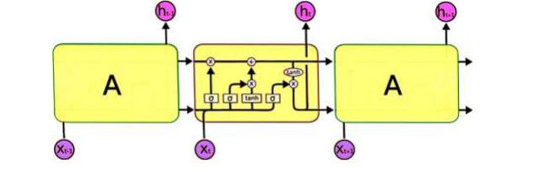

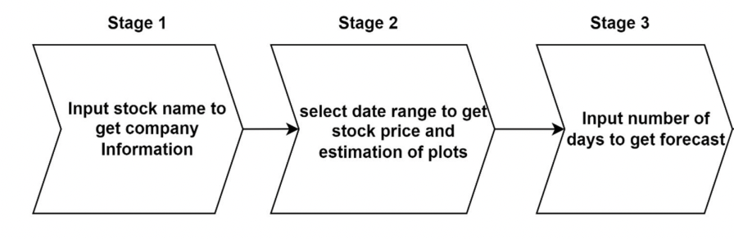

**5. RESULTS AND DISCUSSIONS**

**TECHNOLOGY USED:**

**DASH:**

Dash is a Python framework for building analytical web applications. Dash helps in building responsive web dashboards that is good to look at and is very fast without the need to understand complex front-end frameworks or languages such as HTML, CSS, JavaScript.

**CASCADING STYLE SHEETS:**

Cascading Style Sheets (CSS) is a style sheet language used for describing the presentation of a document written in a markup language. Although most often used to set the visual style of web pages and user interfaces written in HTML and XHTML, the language can be applied to any XML document, including plain XML, SVG and XUL, and is applicable to rendering in speech, or on other media. Along with HTML and JavaScript, CSS is a cornerstone technology used by most websites to create visually engaging webpages, user interfaces for web applications, and user interfaces for many mobile applications

**MACHINCE LEARNING MODEL:**

The Long Short-Term Memory network, or LSTM for short, is a type of recurrent neural network that achieves state-of-the-art results on challenging prediction problems.

### Working Prototype Images

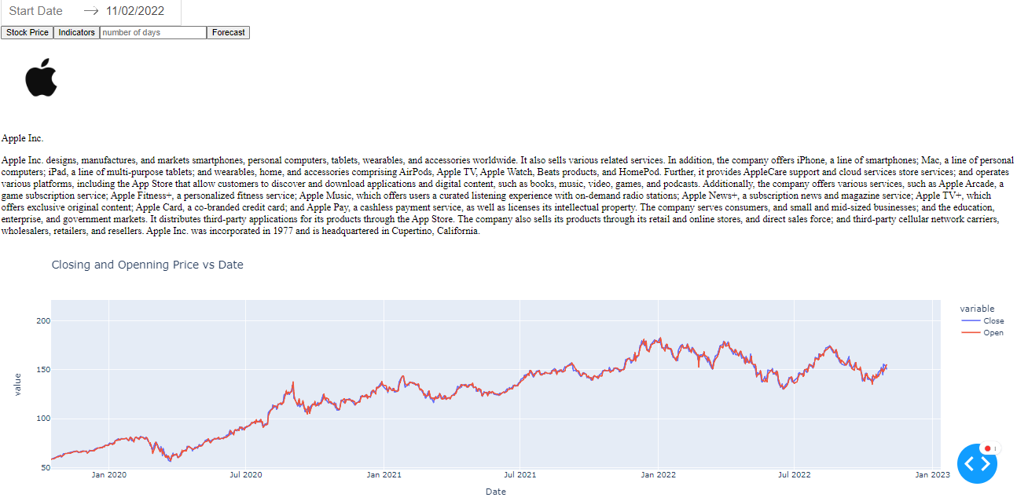

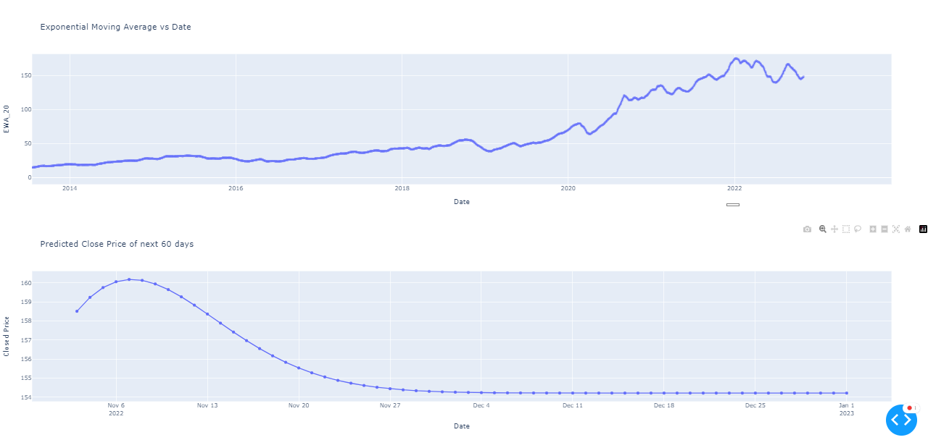

**FUTURE SCOPE**

As per the user Requirement our whole project is designed. We can add an additional constraint to our project. We will also try to make the modifications for machine learning model in our project.

Some of them are:

* The LSTM model can be tuned for various parameters such as changing the number of LSTM layers, adding dropout value or increasing the number of epochs.
* This project can be extended and modified in future by training the model on more features and including some important nonnumeric features as well with the help of a subject matter expert.
* There is a drawback in this that it will work the way we trained it. We have to face a lot of difficulty in trained the data because the model cannot make any changes in itself like the data is transcribed, it works the same way.

**Screenshots of Execution**

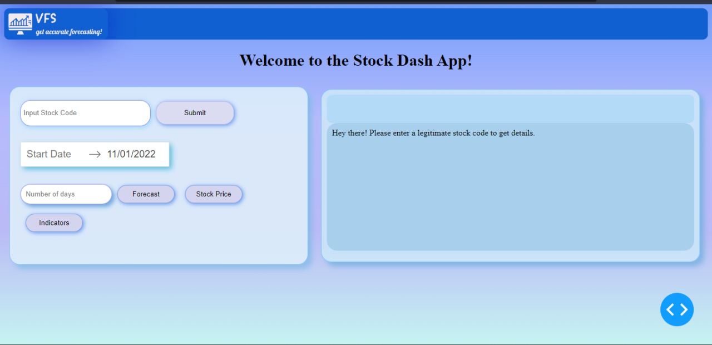

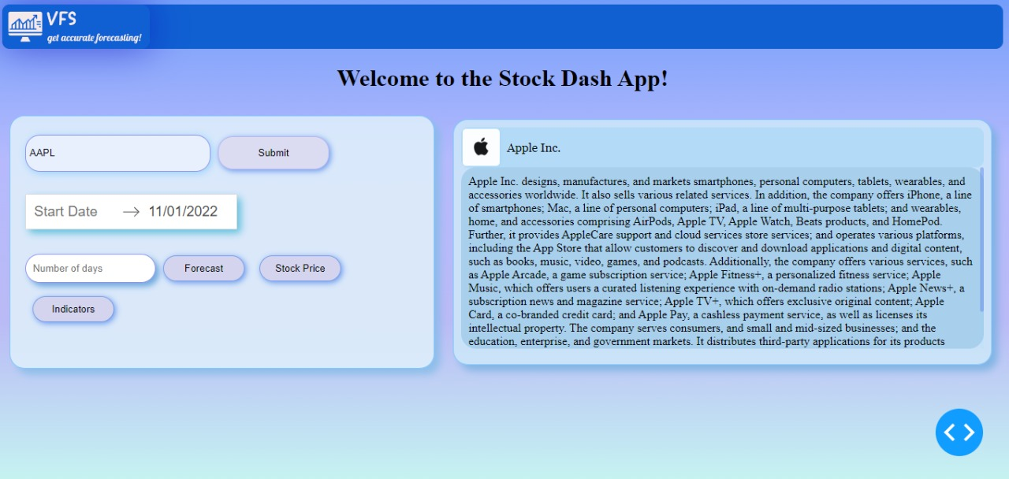

## 

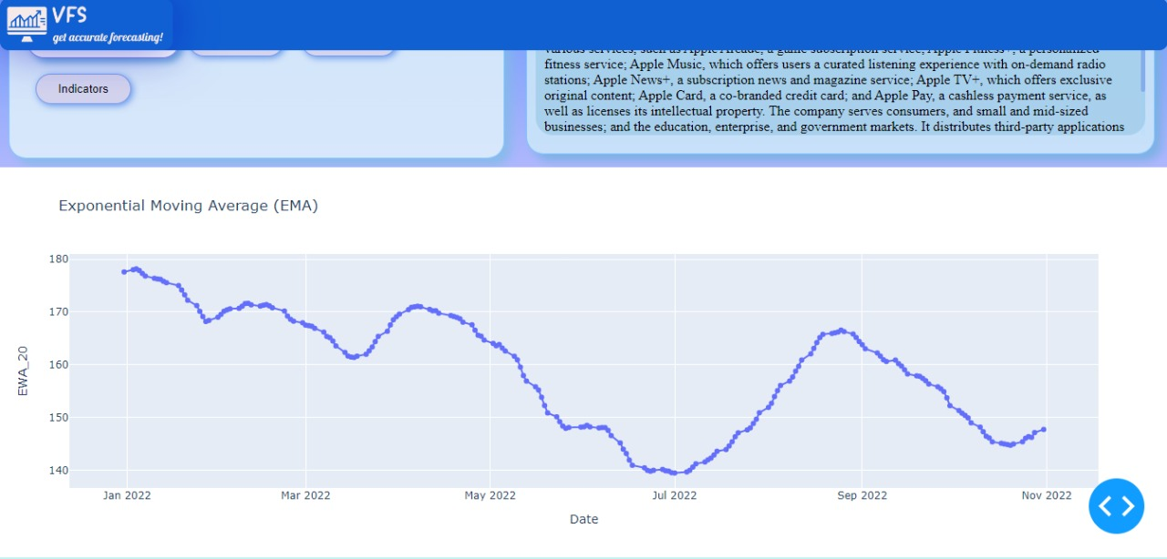

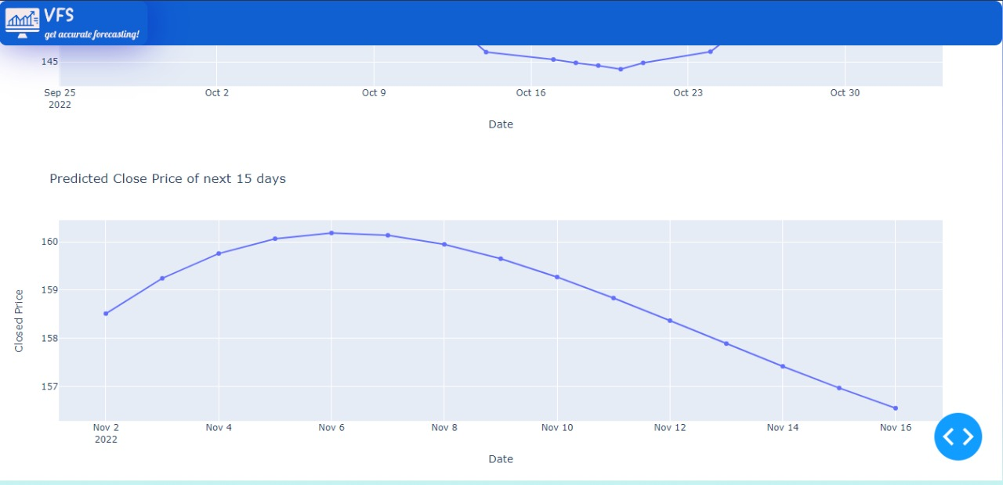

**CONCLUSION**

* Stock market Trading is the most sought after and so its popularity is increasing and researchers ought to find new techniques for prediction.
* Stock forecasting and visualizing technique helps investors and individuals to handle stock market. For predicting the stock prices correctly the forecasting model should have great precision.
* In this project we used deep learning models and LSTMs and RNN units for predicting the stock prices accurately that assists the investors or individuals with correct knowledge about the situation of stock market.
* Visualizing stocks is a risky trend and can often lead to inaccurate value predictions mainly because of how many factors it depends upon so, this model decreases the risk by providing the forecasting output.

## REFERENCES

* <https://www.irjet.net/archives/V6/i9/IRJET-V6I9318.pdf>
* <https://ijarsct.co.in/Paper3509.pdf>
* <https://ijcrt.org/papers/IJCRT2201269.pdf>
* <https://www.jetir.org/view?paper=JETIR2204417>

**THANK YOU**